190905104
Parth Shukla
Lab 4

Sample network

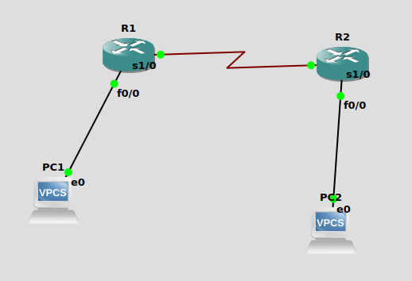
IP addresses:
- PC1(e0) 10.0.0.1 default gateway 10.0.0.2
- R1(f0/0) 10.0.0.2
- R1(s1/0) 20.0.0.1
- R2(s1/0) 20.0.0.2
- R2(s1/0) 30.0.0.2
- PC2(e0) 30.0.0.1 default gateway 30.0.0.2

Setting up IP address of Router is done like this:
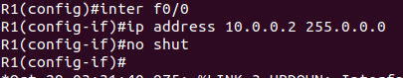

After initialising all IP addresses, we tried to contact PC1 from PC2. However, we could not reach the PC1 since the host is not connected to the destination.
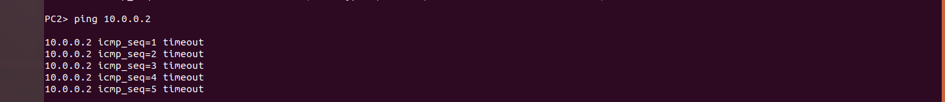

Timeout indicated that our connections are working fine, however, the address needs to be routed in the router to communicate between networks.

We need to route the destination address to be able to reach it.

Routing R2
Routing R1

The format is ip route <destination-server-address> <subnet mask> {next hop IP address}

After routing, you will be able to ping PC2.
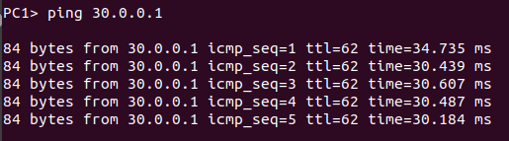
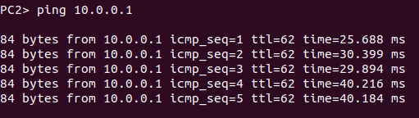
Wireshark on connection between PC2 and R2

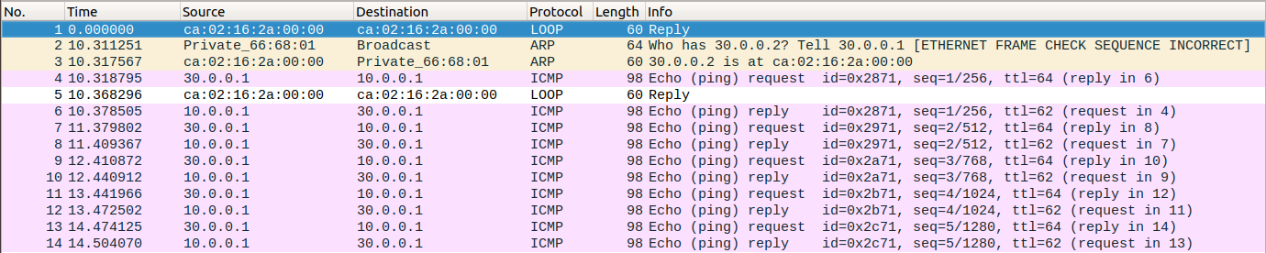
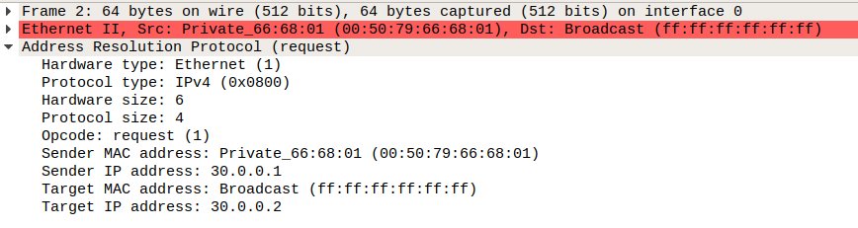

2)

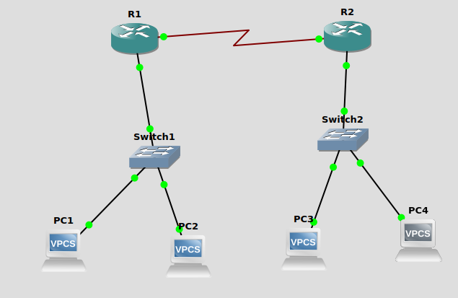
R1 IP address: 20.0.0.1
R2 IP address: 20.0.0.2
R1 e0 IP address: 10.0.0.1
PC1 IP address: 10.0.0.2 defualt gateway 10.0.0.1
PC2 IP address: 10.0.0.3 defualt gateway 10.0.0.1
R2 e0 IP address: 30.0.0.1
PC3 IP address: 30.0.0.2 defualt gateway 30.0.0.1
PC4 IP address: 30.0.0.3 defualt gateway 30.0.0.1

Setting up R1:
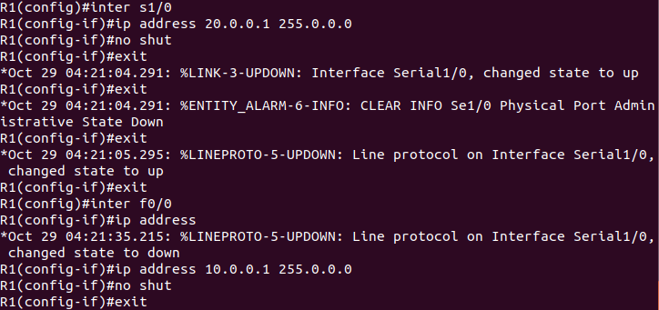

Setting up R2:
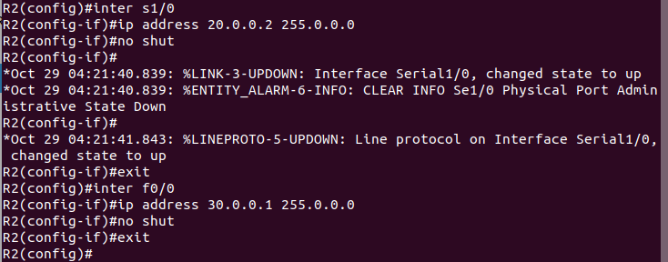

Pinging PC3 from PC4, no routing required since they are on the same network
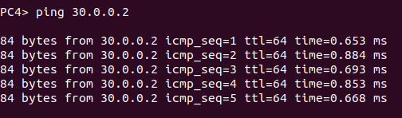

Pinging PC1 from PC4:
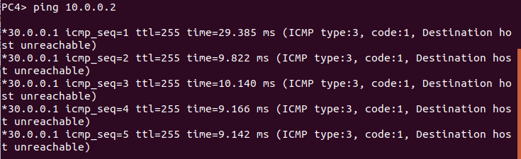
Need to set up routing
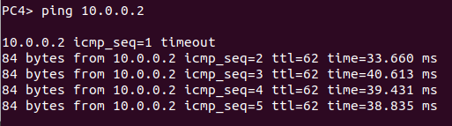
Routing R2
Routing R1

Capturing packets on PC4 when ping request is made.

